**Creating 100 more personas randomly with LLM (ChatGPT), and answering to the same questions as in the questionnaires**

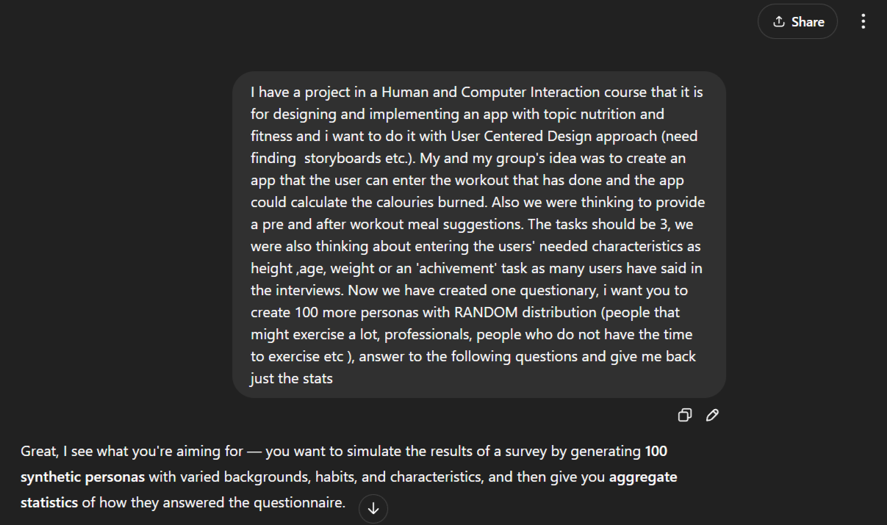

***RESULTS:***

### **1. Age**

* <18: **13**
* 18–30: **50**
* 30–45: **24**
* >45: **13**

### **2.How often do you exercise?**

* Daily: **18**
* Often (2–3 times/week): **41**
* Sometimes (several times/month): **23**
* Rarely: **15**
* Other: **3**

**3. What type of exercise do you usually do?**

* Running / Jogging: **15**
* Walking: **17**
* Lifting weights: **23**
* Home workouts: **20**
* Yoga / Pilates: **8**
* Team sports: **7**
* Martial arts: **5**
* Other: **5**

### **4.Do you currently track calories burned?**

* Yes, with an app: **25**
* Yes, with a wearable: **14**
* I estimate manually: **10**
* No, I don’t track calories: **46**
* Other: **5**

**5. If yes, which apps or devices do you use?**

* **MyFitnessPal**: 13
* **Apple Watch**: 9
* **Fitbit app**: 5
* **Strava**: 5
* **Google Fit**: 4
* **Nike Training Club**: 4
* **Other**: 4

### **6. If not, why?**

* I don’t know how to: **16**
* Apps are too complicated: **8**
* I don’t have access to a fitness device: **18**
* I don’t think it’s accurate: **16**
* I’m not sure how tracking would benefit me: **11**
* I don’t feel the need to: **19**
* Other: **12**

### **7. If you track calories, how convenient is it?**

* Very convenient: **27**
* Somewhat convenient: **41**
* Indifferent / Not sure: **13**
* Not very convenient: **13**
* Not convenient at all: **6**

### **8. How important is it to know calories burned?**

* Very important: **44**
* Somehow important: **34**
* Indifferent / Not sure: **10**
* Not very important: **9**
* Not important at all: **3**

### **9. Do you usually eat before/after a workout?**

* Yes: **38**
* No: **6**
* Sometimes: **46**
* Rarely: **10**

### **10. Is it important to consider what you eat before/after exercise?**

* Yes: **67**
* Yes, but I don’t always do it: **24**
* No: **9**

### **11.How do you decide what to eat before/after a workout?**

* Randomly: **36**
* I search on the web: **21**
* Expert advice (coach, dietitian): **19**
* I usually don’t eat: **16**
* Other: **8**

### **12. Have you ever felt confused about what to eat?**

* Yes: **38**
* Maybe: **21**
* No: **26**
* I usually don’t eat: **15**

### **13. If yes, what was the reason?**

* Too lazy to search/choose: **22**
* Didn’t know what to eat based on calories: **16**
* Didn’t know what to eat for fitness goals: **29**
* Never paid much attention: **23**
* Other: **10**

### **14.Would you like snack suggestions for...?**

* Pre-workout: **24**
* After workout: **11**
* Both: **58**
* None of them: **7**